**Contemporary Issues in Software Engineering**

**Semester 2, 2022**

**Worksheet 3 Ass1A: The MERN Stack**

**To be submitted by End of Week 4 Tutorial**

**Theory Overview of MERN Revision: A Simple web application using the MERN tech stack.**

The **high-level view of the MERN stack** is the use of four technologies used in tandem and all based on one programming language – JavaScript.

[**React.js**](https://reactjs.org/) **Front End (link to documentation)**

The top tier of the MERN stack is React.js, the declarative JavaScript framework for creating dynamic client-side applications in HTML. React lets you build up complex interfaces through simple Components, connect them to data on your backend server, and render them as HTML.  React’s strong suit is handling stateful, data-driven interfaces with minimal code, and it has all the bells and whistles you’d expect from a modern web framework: great support for forms, error handling, events, lists, and more. Go to <https://reactjs.org> for a great interactive tutorial. Also an overview at <https://www.youtube.com/watch?v=jeNXbJq5o5g>

[**Express.js**](http://expressjs.com/) **and** [**Node.js**](https://nodejs.org/en/about/) **Server Tier (links to documentation)**

Node.js is a cross-platform JavaScript runtime environment that was originally created for Google Chrome and open-sourced in 2008. Node.js is built on Chrome’s V8 JavaScript engine and is intended to allow developers to build scalable network applications and execute JavaScript code outside of browsers.

Express.js server-side framework, running inside a Node.js server. Express.js is described as a “fast, unopinionated, minimalist web framework for Node.js,”. Express.js has powerful models for URL routing (matching an incoming URL with a server function), and handling HTTP requests and responses.

[**MongoDB**](https://www.mongodb.com/) **Database Tier (link to documentation)**

If your application stores any data (user profiles, content, comments, uploads, events, etc.), then MongoDB is simple to interface with the React/ Express /Node stack. JSON documents created in your React.js front end can be sent to the Express.js server, where they can be processed and (assuming they’re valid) stored directly in MongoDB for later retrieval. For a SaaS application hosted in the cloud, we can use Atlas - a MongoDB instance hosted in the cloud.

By making XML HTTP Requests (XHRs) or GET or POST, PUT, DELETE from your React.js front-end, you can connect to Express.js functions that power your application. Those functions in turn use MongoDB’s Node.js drivers, either via callbacks or using Promises, to access and update data in your MongoDB database.

**READ THIS: Theory and resources – creating a web app with the MERN stack**

Typically **creating a MERN** stack has the following steps (not necessarily in this order):

1. Initialise the project with a Git/GitHub workflow and project folders
2. Create the template code and folders for a front-end Single Page Application (SPA) using React. (e.g “create-react-app” script)
3. Clean up the template – delete unnecessary stuff
4. Create react component that are part of the UI
5. Create menus, navigation bars, forms, inputs, navigation etc for the React front-end
   1. There are react libraries and components
      1. **react-select** for drop downs

<https://www.positronx.io/react-dropdown-select-tutorial-with-react-select/>

* + 1. **react-table**  for creating table sorting, filtering etc

<https://blog.logrocket.com/complete-guide-building-smart-data-table-react/>

* 1. css files can be used for formatting UI components
  2. **material-ui** is a popular UI library for React with tables, forms, buttons, dropdowns and so on.
  3. <https://material-ui.com/components/tables/>

<https://material-ui.com/getting-started/learn/>

* 1. **formik** is a popular forms library for React, including input validation. <https://www.youtube.com/watch?v=bMSHmf_ckM8>
  2. <https://formik.org/docs/tutorial>
  3. **bootstrap** is a popular UI library similar to material-ui
  4. often dummy data in the frontend (e.g. in a data.js file in the frontend) is used to test out the frontend with no backend yet.

1. Create “pages” as components using the react-router-dom library <https://medium.com/@ipenywis/intro-to-react-router-for-beginners-multiple-page-apps-461f4729bd3f>

<https://www.freecodecamp.org/news/react-router-tutorial/>

1. Create the backend Node/ Express / Nest.js server including some APIs (often Postman or Slumber are used to test the APIs). Often dummy data in the backend are used for testing APIs
2. Connect the frontend UI to the and backend server using Express / Nest routes and the **axios** library (or similar) as well as the **cors** library (feel free to look these up and see what their purpose is).
3. Setup the MongoDB database (local or in the cloud). We will set up a MongoDB database instance (a cluster) in the cloud using **MongoDB Atlas**
4. Connect the backend server to the MongoDB database – so we can get and receive data from the database (CRUD requests -Create/Read/Update/Delete). The **mongoose** library is used.
5. Deploy the backend and frontend (in that order!) to production (so users have access) in the cloud with Vercel (or Netlify another cloud service). (i.e. users just type a URL address into the browser to run the app)

This worksheet will bring together all these ideas to create a simple MERN web app.

The worksheet relies on you watching some videos on YouTube (and taking notes) and reading some online tutorials to achieve the desired skills so we can make progress on the SEPER app for Peter the PO.

I have chosen videos and tutorials that model the thinking needed to use MERN and reinforce principles. Mostly they are over-simplified but should give you a way forward with the SEPER product we are starting to make.

Remember to **look for PRINCIPLES**! Think about what you are doing.

**Be curious, experiment**, read about different ways of doing things (there is usually more than one way).

**What we need to be able to do for CISE and the SEPER product development**

There is a lot that *could* be learned about using the MERN stack to create dynamic web apps. In this course you will need to learn just enough to deliver *some* functionality for the Software Engineering Practice Evidence Repository (SEPER) app. This will involve some simple forms and data display as a minimum so that the Product Owner (PO) can test the idea out.

The SEPER application should allow practitioners to be able to find the level of evidence that there is in academic articles that supports or refutes the claimed benefits of different SE practices (eg. what is the level of evidence that using TDD will improve code quality -compared to not using TDD). The SEPER app needs the following functionality to test the idea out:

1. A way to select an SE practice (e.g., TDD) that we want to get the benefits that are claimed about, as well as the level of evidence (eg. strongly supports, weakly refutes) for those claimed benefits.
   1. The user should only be able to select from SE practices that we have evidence of claimed benefits for in our database.
   2. This could be a dropdown list of SE practices that are in our database and that we can select from to return the list of claims and evidence from our database for the selected SE Practice (from the dropdown).
      1. One way to do this is to use the “react-select” library in the React component library.
2. A way to view the level of evidence for each claimed benefit for the SE Practice selected.
   1. It will be useful for the user to see other information about the source of the evidence (the article analysed by the analyst and submitted by a submitter) -such as article title, article authors, journal name, year of publication.
   2. This could be a table of data that can be sorted and filtered.
      1. Each row would be evidence of different claimed benefit from a specific article, each column would be a different piece of info about that claimed benefit and evidence (title, etc)
      2. The table should be sortable on any column
      3. The table should be filterable by claimed benefit (and maybe year range of publication, and maybe level of evidence)
      4. One way to create a table in React is using the react-table library (or
3. An input form for submitter (anyone) to submit an article they think is relevant for our evidence database.
   1. The article should be about a SE practice and have some evidence about a claimed benefit(s) for this SE practice.
   2. This article may or may not be accepted (moderator will decide)
   3. If it is accepted then the analyst will read the article and decide on the level of evidence for each claimed benefit in the article and enter that into our SEPER database.

**How to learn to do the things we need to do.**

This course is about the practices around the coding (CI/CD, TDD, mob/pair programming, planning, retrospectives, code reviews, code quality testing etc), so we do **not** want to spend too much effort becoming expert in JavaScript/Typescript or React or Express/Nest/Node. Rather we just want to learn **enough** so we understand the **principles and can create basic functionality.**

In industry it is common to have to learn a new language or framework or tool – they are changing almost weekly, so this is a useful skill to develop – learning how to learn from diverse sources.

To learn quickly it is useful to watch others model the thinking and coding – **BUT only if you take notes.** Otherwise it is too passive, and you will not retain or learn much.

Then the ONLY way to make this useful so YOU can do it, is to **actually do it yourself !**

This is why we are using worksheets to encourage you to read, watch **and do**.

Many people in industry learn from tutorials online or take online courses, and I am sure many of you do this already. It is part of the new way of learning – not just classroom learning, but the sources of information and practice can also be from podcasts, blogs, videos, websites and so on.

The problem is there are worthless, out-of-date, or even plain wrong videos and tutorials on the web. And there are LOTS of videos and tutorials to sift through. The problem becomes finding the good ones. I spend some time finding good ones each year and hopefully you find the ones I direct you to useful.

**Worksheet Instructions**

Follow the instructions for the following tutorial that creates a simple application to manage information about books. **TAKE SCREENSHOTS AS EVIDENCE** of doing the tutorial. Experiment. Note down anything you learn from doing this tutorial. Try converting the usage of **javascript** into **typescript instead** – this will help you in the next part. A reminder you can always read documentation if you forget how to use typescript here: <https://www.typescriptlang.org/>

NOTES:

1. You will need to create a local project folder with a Git repo and also synchronise it with a GitHub repo.
2. Remember to take lots of screenshots! Also remember to note down learning and describe challenges and trick you found.
3. Look at the comments in the tutorial – there are some interesting problems people have!
4. Look at the links in the above to get documentation about each technology from the creators
5. Be curious and experiment!
6. This app is not deployed to production in the tutorial– I have included tutorials for deploying a MERN app to Vercel in the next section
7. See if you can deploy this app to Vercel

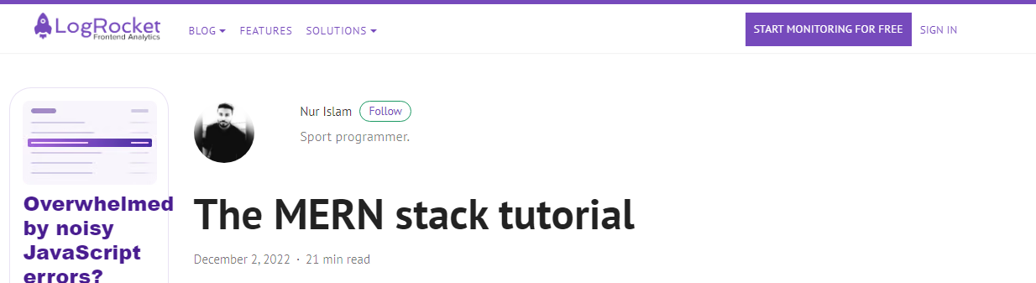

**Tutorial**:   
<https://blog.logrocket.com/mern-stack-tutorial/>

**Additional challenge - Adapt the MERN Tutorial to MNNN (MongoDB, Next.js, Nest.js, Node.js) & Deploy to Vercel**

This step is optional but will greatly assist you for the week 4 exercise and the assignment.

Modern technologies such as nest.js and now Next.js are frameworks that keep innovating the development field. This additional challenge will assist you for the assignment and help you understand how to now use Next.js with typescript.

You can read about Next.js here: <https://nextjs.org/docs>

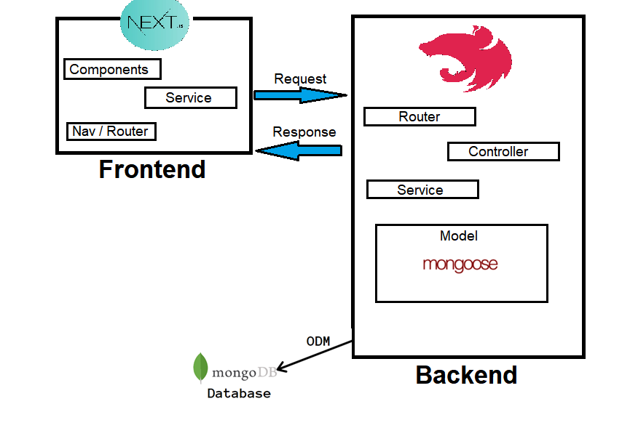

**Before starting:**

I always suggest you get yourself familiar with the technologies you are using. I suggest you first run this command:

> npx create-next-app@latest frontend-week3

Which will prompt you to create a Next application follow these selections:

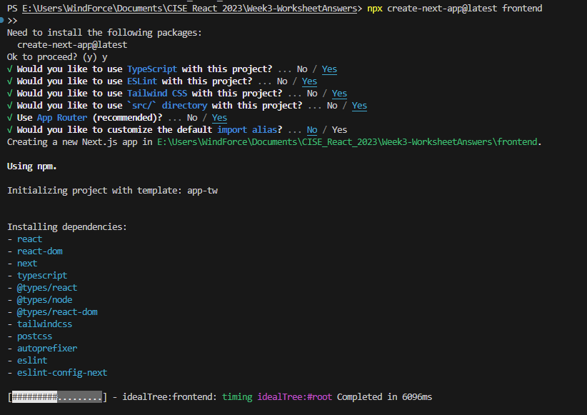

Before you can use the command npm start you must first run this command:

> npm run build

*Do you know why?*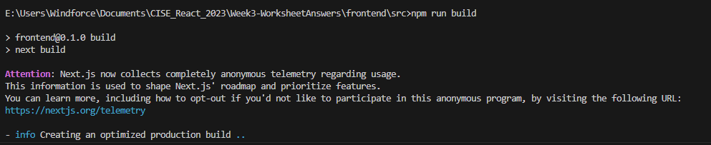

Now you will be able to use:> npm start

Note you can also run a development build with command without needing to *npm run build* first

> npm dev

You should see this as the default display page – Click the links **EXPLORE** understand what this technology is (***you will be using Vercel to deploy, and this page provides helpful resources to learn from***)

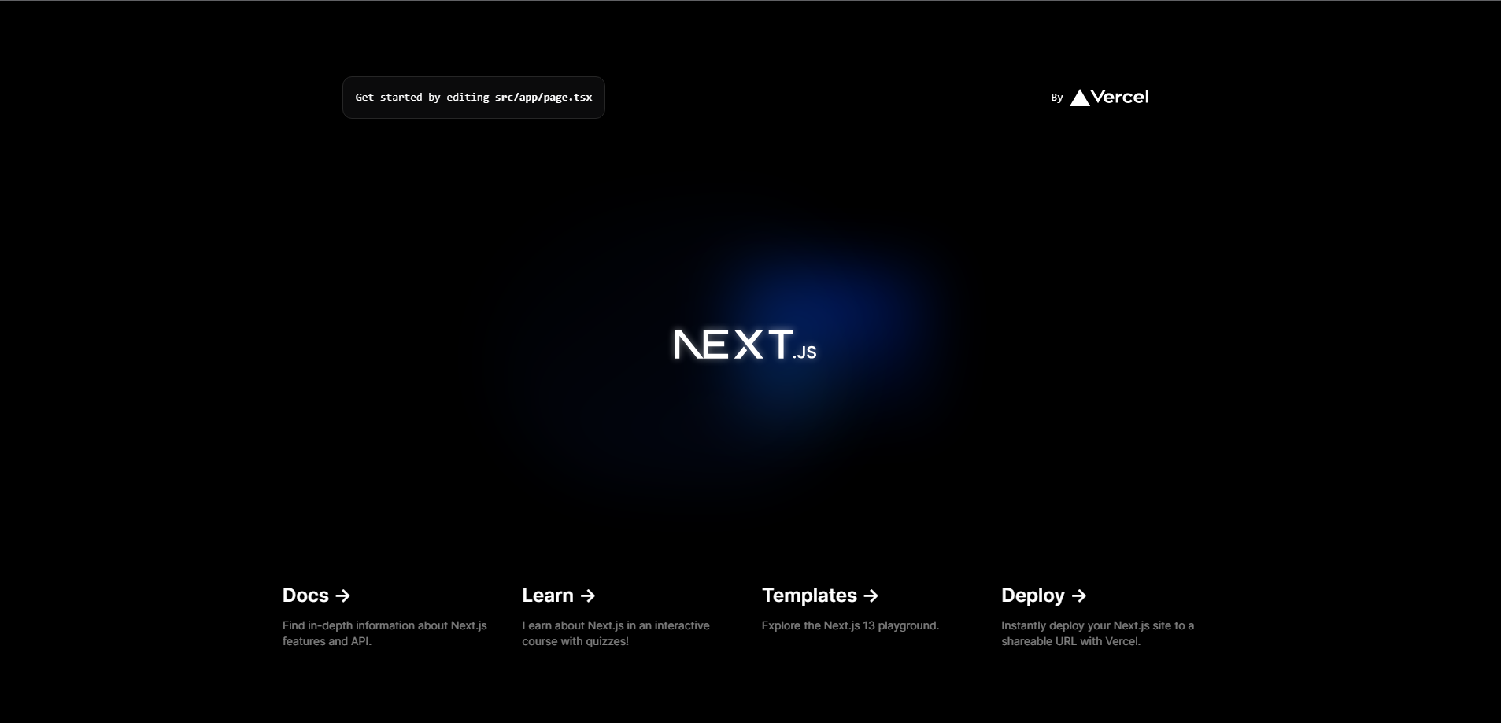

**Helpful Links:**1. <https://vercel.com/docs/getting-started-with-vercel>

2. <https://www.mongodb.com/basics/technology-stack#:~:text=A%20technology%20stack%20is%20a,together%20to%20build%20any%20application>.

3. <https://dev.to/yakovlev_alexey/creating-a-project-with-nestjs-nextjs-3i1i>

4. <https://www.mongodb.com/developer/languages/javascript/nextjs-building-modern-applications/>

**Evidence to Be uploaded to Canvas as well as Checked off by the Tutor by Week 5**

1. Screen shots of going through each step of the MERN stack tutorial that creates the Book app. Include some written notes beside the screenshots that explain what is being done and anything new you learned or any tricks or mistakes you made.

Add screen shots and notes here (include screen shot of GitHub – code for frontend and backend; screen shot of the package.json file; screen shot of the MongoDB database created; screen shot of the app running locally.

1. The Vercel URL of your MERN app which has successfully been deployed to Vercel
2. A screenshot of the app running on a browser being served by Vercel. Describe any new things you learned or any issues you had.
3. What is the difference in purpose between a Route in React and a Route in Nest?
4. What react library options are there to create each of the following:
   1. **Drop down widget** (such as needed to select the SE practice in the SEPER app)
   2. An **input form** (such as the article submission form needed for the SEPER app.
   3. A data **display table** (such as needed to display the evidence level and claims for the SEPER app).

**OPTIONAL EXTRAS – EVIDENCE (to make sure you get an A to A+)!**

1. Show screenshots and write explanations showing you were able to (or tried to) use GitHub actions to automatically deploy your Book app using Vercel.
2. Show screenshots and written explanations of setting up the linter and prettier with VS Code and create-react-app,using AirBnB rules, and including using “fix” with the linter
3. Show screenshots and written explanations of setting up “husky” and “lint-staged” to automatically lint locally any files you stage with “git add”.